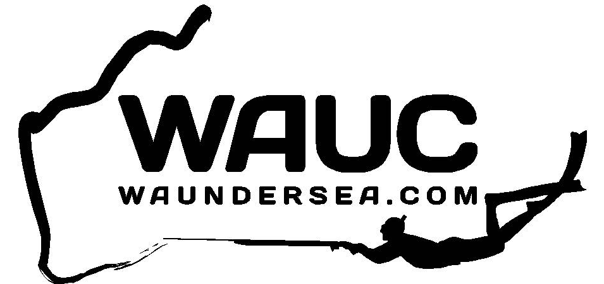

YAZBECK Geraldton Spearfishing Competition 2018

- The competition will be on Sunday, June 3rd 2018.
- Pairs must dive from the same boat
- Entry is free and open to all financial members of the West Australian Undersea Club Inc.
- Start: Any time after sun up.
- Finish: 3:00pm at Marina Park, Stella Maris Drive (next to the Marina ramp).
- Each pair must have signed off by the notified finish time
- Weigh-in commences at 3.30pm
- It is a freedive only competition
- All divers are strongly encouraged to tow a float with flag.
- Competitors must be immersed in the water at time of spearing the fish.
- One fish of each species to be submitted per pair.
- Burleying is only permitted using fish speared on the day.
- Prizes awarded for 1st, 2nd and 3rd pairs, most meritorious and mystery weight fish (open only to those who haven’t won a prize).
- Competition organizer has final say on prize allocation.
- Should the day be cancelled, the competition will be postponed to the following day/weekend
- It is everyone’s responsibility to be aware of marine sanctuary boundaries. Anyone diving in a sanctuary will be disqualified.
- All fish to be submitted gutted and gilled and divers should ensure that fish are thoroughly cleaned. If, however you believe you may have a record fish, certified club scales will be available at the sign off area prior to gutting and gilling.
- Boat skippers are permitted.
- Boat Skipper to ensure dive flag is in use while competitors are diving
- Ensure to log in and log off with Sea Rescue if diving from a boat (9964 3543).
Any questions, call Michael Treble – 0499 281 430

