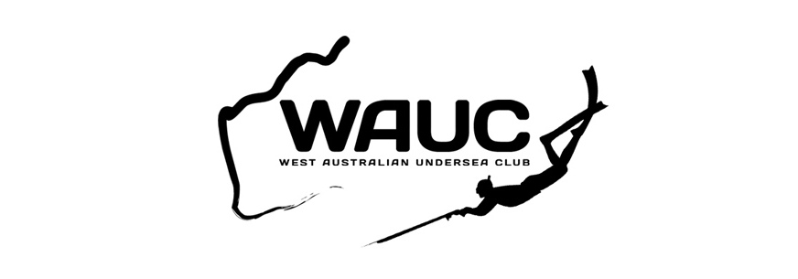
DIVE and FISH METRO CRAY COMP 2015 RULES

- Participants must catch their crayfish whilst breath hold diving.
- Crayfish must be caught on the day of the competition.
- Entrants are to be financial members of WAUC prior to competition day.
- Contravention of Fisheries WA regulations will lead to immediate disqualification.
- Competition date is Saturday November 14, 2015. If weather is unsuitable then event is postponed until next weekend.
- Start is at first light on day of the event.
- Sign off is 1pm on the beach at the Rottnest Island army jetty. Competitors arriving after this time will be ineligible to enter.
- Weigh-in commences at 1:15pm
- One crayfish weighed per competitor.
- Prizes for: 1st, 2nd, 3rd, mystery weight and lightest legal crayfish with all its legs present (don’t have to be attached). Additional prizes dependent on turnout. Judges decision will be the final word.
By participating in this competition you are deemed to be aware of the following.
- I agree that it is my own responsibility that I am physically fit and qualified for engaging in the Dive and Fish Metro Cray Comp 2015
- The activity of breath hold diving involves the danger of “shallow water black out” if not conducted with caution and due care on your part. Have at least a general understanding of the term “shallow water blackout”.
- I hereby indemnify and agree to keep indemnified West Australian Undersea Club, it’s member clubs, and it’s individual members, their agents, all appointees and assigns against all claims whatsoever by me or the child or by any person claiming through me, or through the child on my behalf, in any way arising, and this discharge may be pleaded in bar to any such claim.

